MEDPLUS
Daze Thomas/Assistant Professor, Dr.P.Sumathi/HOD, Vivega.B/UGScholar, Praiseline.I/UG Scholar , Soundhar.P/UG Scholar, Velaga Buvanesh Sai.V/UG Scholar.
Department of Artificial Intelligence,
SNS College of Engineering, Coimbatore, India.
vivega.b.ad.2021@snsce.ac.in
praise.i.ad.2021@snsce.ac.in
soundh.p.ad.2021@snsce.ac.in
velaga.ad.2021@snsce.ac.in

ABSTRACT:

The android operating systems(AOS) based electronics devices such as smartphones and computer tablets are extensively used for many purposes like instant messaging, gaming, word processing, internet and download number of applications online. There are different kinds of healthcare applications developed in android smartphones which help patients and their care gives to reduce time and efficiency. This project proposed such new application which satisfies our day to day needs, about hospital management system. Hospitals are the largest and most complex organizations where health care is provided. The patients can search the hospital based on their needs. In this research work, an application is developed that locates the hospital a with the desired medical specialist. The nearest position of hospitals is calculated with a built-in feature of Global Positioning System (GPS) in Smartphones and finds the route from their current location through Google Map application Program Interfaces (API). With the help of this application, a patient can find the nearest hospital according to specialized consultant availability. A comprehensive profile of doctor and hospital is available in the application including the website, mailing addresses and contact numbers.. It can quickly access the information and it also ensures the hospital which can provide high quality patient care and services. The user can not only find all the hospitals in the city , but also one can make a choice of best hospitals based on rating and the doctors he chooses to have . The user has the facility to make a call directly to the hospitals and can also obtain the detailed review of the hospital he chooses.
KEYWORDS:
GPS, AOS, Google Maps Application, Hospitals, Doctors.

- INTRODUCTION:

Domain and Industry Vertical - IoT – Smart city and health care:

We have chosen our DT project under the Fintech. Our Moto is to make India smart and developed country in the near future. As of now we are as a team designed this project as to make an ‘Medfit’ using IOT. There are many different application categories available for download from the online Google play store. Everyday thousands of new apps are uploaded in the play-store. The no.of applications related to health care are more available in the medical category which are helpful in diagnosis of vital sign parameters, vaccinations schedule, medicine reminder. These kinds of applications lies in mobile-health technology. Many of the applications determine the location of clinics and city hospitals. To search the nearest hospital with the specialization is the unique idea of this application.
Places were we used:
We use this application to create a list of hospitals based on location and specialization of the doctors for the problem entered by the user on a mobile platform
End users:
Lastly our DT project is used by the common people for searching hospitals around them based on the given ratings.
II. OBJECTIVES:

The mobile application allows the users to review the hospital performance metrics with access. This mobile app contains performance and list of hospitals based on the specializations. Our moto is to safeguard patients from the fake persons who were creating brands for their company and getting lot of amount for the treatment.It can quickly access the information and it also ensures the hospital which can provide high quality patient care and services. The user can not only find all the hospitals in the city. But also one can make a choice of best hospitals based on rating and thedoctors he chooses to have

III. DIAGRAM: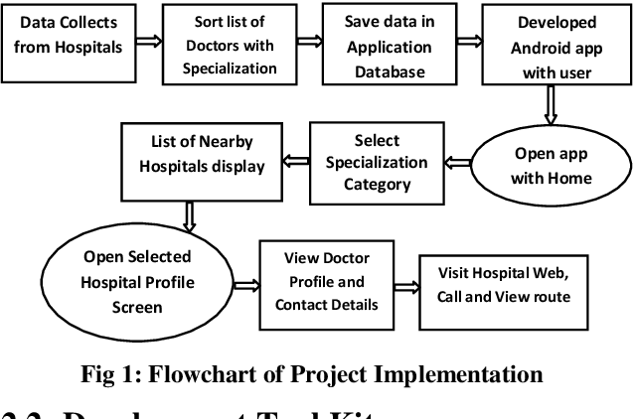

IV.WORKING:

- Improved efficiency and speed – This app can enhance healthcare delivery with more efficiency, as they can handle multiple queries and requirements at a time.
- Easier and convenient to use – This app can be accessed at any time of the day.They have a 24/7 doctor availability monitoring system.
- Save time – With these apps, the patients can easily connect with the healthcare provider for consultation. It saves traveling time between home and the healthcare center and also requires fewer visits as compared to the traditional approach.

PROPOSED DESIGN:
The main objective of this “Medplus” is to develop associate application that locates the highest hospital. The highest position of hospitals is calculated with a constitutional feature of worldwide Positioning System in wise Phones and finds the route from their current location through Google Map Program Interfaces (API). associate informative survey of varied hospitals. With the help of this application, a patient can notice the highest hospital. A comprehensive hospital is on the market among the applying. The golem operational system (AOS) primarily based electronic devices like Smartphones and pc tablets are extensively used for several functions like instant electronic communication, gaming, data processing, net and transfer variety of applications on-line. There are completely different sorts of health care applications developed in golem Smartphones that facilitate patients and their caregivers to scale back time and value potency. This project planned such new application that satisfies our day to day desires, concerning hospital management system. The patient will search the hospital supported their desires. This application provides the accessible hospital supported the patient request. The planned application is developed that locates the closest hospital with the required physician. The closest position of hospitals is calculated with an in-built feature of worldwide Positioning System in Smartphones and finds the route from their current location through Google Map computer program Interfaces (API). With the assistance of this application, a patient will realize the closest hospital in keeping with specialized adviser convenience. A comprehensive hospital is out there within the application together with the web site, mailing addresses and get in touch with numbers. The developed golem application could be a user friendly app. Instead of creating the patients shift from hospital to hospital for needed service and treatment, we tend to offer all necessary info concerning all the hospitals from the applications itself. There square measure 2 kinds of applications concerned during this project. The administrator of the applying adds all the small print of cities, areas, hospitals. The users or patients will get registered with the applying to avail all the service. The users will read the hospitals and services provided, and additionally perform search supported town, hospitals. This can refine their search so as to search out the any hospital. The projected application could be a terribly various application which might simply be accessed by the registered members of the applying. Users will access the closest hospitals by victimization the google map feature. Victimization this location of the user the applying fetches the closest hospitals and provides the small print concerning the hospital and their services. Supported the results obtained, patients will choose hospital and obtain the route map for the chosen hospital by users severally.

V. CONCLUSION:
The conclusion states that a basic and up-to-date medical category application is designed to help the patients and caregivers to determine the nearest hospital with a specific specialization field. The hospital names along with their address and route are determined by Smart-phone GPS receiver. With the help of Google Map, the distance and route to each of the hospital is displayed for the user. Specialized list of doctors in each hospital in a single application is also useful for later appointments. The future scope of this application is to develop the availability of specialist doctor on a real-time basis near patient’s location. This development will also give an opportunity to book online appointment which facilitates the patients by saving their time. The current working health-care applications are used by hospital management. Thus it can be concluded that the proposed application effectively provides the solution to current working method and this application can be used by both hospital management and public also.In future, more advanced features will be integrated with this system which will provide users with more accuracy and user-friendly. The proliferation of software applications has led to developments in the field of fintech, which has considerably widened their scope of application.
V. REFERENCES
[1] J.S. Olshaker, N.K. Rathlev, &Emergency Department overcrowding and ambulance diversion: The impact and potential solutions of extended boarding of admitted patients in the Emergency Department, J. Emerg. Med. 30 (2006) 351–356. Doi: 10.1016/ j. jemermed. 2005.05.023
[2].N.Esfandiari, M.R.Babavalian, A.M.E. Moghadam , V.K. Tabar, Knowledge discovery in medicine: Current issue and future trend, Expert Syst. Appl. 41 (2014) 4434–4463. Doi: 10.1016/j.eswa.2014.01.011.
[3]. H.C. Koh, G. Tan, Data mining applications in healthcare, J. Healthc. Inf. Manag. 19 (2011) 65.
[4]. C. Baker, Accident and Emergency Statistics, England, 2015. www.parliament.uk/briefing- papers/sn06964.pdf.
[5]. J. Boyle, M. Jessup, J. Crilly, D. Green, J. Lind, M. Wallis, P. Miller, G. Fitzgerald, Predicting emergency department admissions, Emerg. Med. J. 29 (2012) 358–365. doi:10.1136/emj.2010.103531.

[6]. S.L. Bernstein, D. Aronsky, R. Duseja, S. Epstein, D. Handel, U. Hwang, M. McCarthy, K.J. McConnell, J.M. Pines, N. Rathlev, R. Schafer Meyer, F. Zwemer, M. Schull, B.R. Asplin, the effect of emergency department crowding on clinically oriented outcomes, Acad. Emerg. Med. 16 (2009) 1–10. doi:10.1111/j.1553-2712.2008.00295. x.

